**Task 1.** In a country there are several airports. Airport A is directly connected to 23 other airports. Airport B has a direct connection to 3 other airports. Each airport, except A and B, is directly connected to 10 other airports. Prove that there is an airline route (maybe with flight changes) between A and B.

**Solution**

We can describe this situation with a graph, where vertices correspond to cities and edges correspond to airline routes between cities. Then we can consider number of connections of every city as a degree of the corresponding vertex.

Suppose vertices A and B are not connected, so they belong to two disconnected subgraphs. Then subgraph with vertex A has only one vertex (A) with an odd degree. This contradicts the handshaking lemma, which states, that any graph can have only even number of odd degree vertices. Hence such a subgraph can’t exist and A and B are not disconnected.

**Task 2.** Consider an Erdős–Rényi random graph on 4 vertices with p=1/2. Calculate the probability that this graph is connected.

**Solution**

A random graph on 4 vertices can contain up to $\frac{4⋅3}{2}=6$ edges.

We can enumerate the edges and represent such a graph with a binary number of 6 digits, where 1 on n-th position corresponds to existence of n-th edge, while 0 means there’s no such edge in the graph.

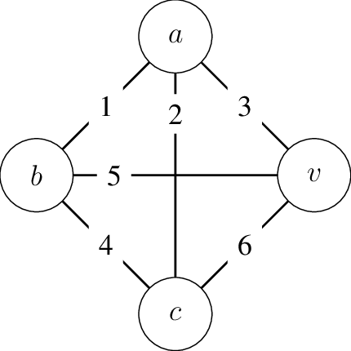There are $2^{6}=64$ such numbers from 000000 to 111111. As p=1/2, these numbers are all equally probable.

Graph on 4 vertices can be disconnected in several cases: (i) if it consists of two disconnected subgraphs on 1 and 3 vertices or (ii) if it consists of two disconnected subgraphs on 2 vertices, (iii) if it has several isolated vertices.

First let’s consider the probability of an isolated vertex in such a graph, for example vertex a (on the picture), while other three vertices are connected.

For this to happen edges 1, 2 and 3 should not exist, while there should be at least two edges out of 4, 5, 6.

Such situation is represented by numbers 000011, 000101, 000110, 000111. There are 4 such numbers $.$ As such situation can occur with any of 4 vertices, there are 4⋅ 4 = **16 numbers**, that describe this case.

Second case is described by two disconnected subgraphs on two vertices each. Such situation is possible if graph contains only edges (1, 6), (2, 5) or (3, 4), so it corresponds to numbers 100001, 010010 and 001100.

There are 3 such numbers.

Third case: two or more isolated vertices. Two vertices can be isolated if graph has only one edge, so it corresponds to numbers, which have only one 1 in them, like 000100. There are **6 such numbers**.

Three vertices can’t be isolated, as it leads to the last vertex isolation as well, so it basically corresponds to a graph on four disconnected components which has no edges. There is only **one number** 000000, which corresponds to such a situation.

All in all we have 16 + 3 + 6 + 1 = 26 numbers which correspond to disconnected graphs on 4 vertices, so there are 64 – 26 = 38 numbers, which correspond to connected graphs on 4 vertices. As such, probability of such a random graph being connected is 38 / 64 = 19/32 = 0.59375

**Task 3**. Which of the following pictures can be drawn in one stroke of pen, without traversing a line twice (like a Euler path in a graph)?

**Solution**

For Euler path to exist there should be 0 or 2 vertices of odd degree in a graph. As such we can draw the first graph in one stroke of a pen (all of it’s vertices have even degree), but we can’t draw the second one, as it has more than two odd degree vertices.

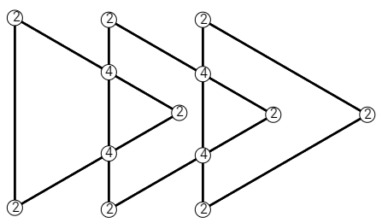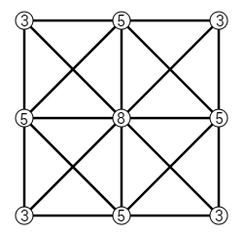

**Task 4.** Does there exist a graph with 5 vertices which have the following degrees: 2, 4, 4, 4, 4?

**Solution**

No, there is no such graph.

Assume there is such a graph, let vertex A have degree 2 and vertices B, C, D and E have degree 4.

As vertex B has degree 4 it is connected to 4 other vertices: A, C, D, E.

Vertex C is also adjacent to 4 other vertices: A, B, D, E.

Same can be said about vertex D (which is connected to A, B, C, E) and vertex E (connected to A, B, C, D).

We can see, that each vertex B, C, D and E are connected to vertex A and as such, vertex A should also have degree 4. This contradicts the assumption, so we can conclude that graph like this doesn’t exist.

**Task 5.** A connected graph on 10 vertices has 15 edges. What is the maximal number of edges one can remove so that the graph remains connected?

**Solution**

The maximum number of edges, that can be removed, is **6**.

After removing 6 edges from any connected graph on 10 vertices with 15 edges in such a way, that it becomes a tree, it remains connected. Here is an example.

Graph in the picture below has 10 vertices and 15 edges.

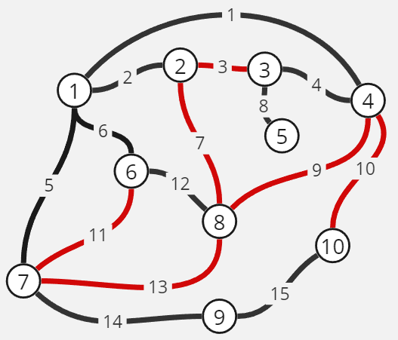

After removing 6 edges this graph can be transformed to a tree-like view:

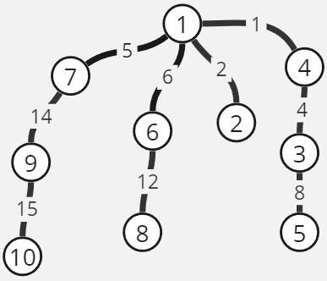

It is obvious, that removing more than 6 edges leads to graph becoming disconnected. For example, in the graph above removing any of the remaining edges, even one more, will break down the tree into two connected components.

**Task 6.** A graph on 6 vertices has 11 edges. Prove that this graph is connected.

**Solution**

Assume this graph to be disconnected. Maximum number of edges in such a graph occurs when one of the connected components consists of one vertex, while the other component contains a complete subgraph on other n-1 vertices. In our case, such a subgraph has 5 vertices and $\frac{5⋅4}{2}=10$ edges. But graph in the task has 11 edges, which is more than 10, so the graph in the task is connected.

We can also check this fact using inequality $m>\frac{\left(n-1\right)⋅\left(n-2\right)}{2}$, which implies graph connectedness (m is number of edges, n is number of vertices). In our case 11 is greater than $\frac{\left(6-1\right)\left(6-2\right)}{2}=\frac{5⋅4}{2}=10$, hence graph is connected.

**Task 7.** A graph on 10 vertices has 3 isolated vertices (degree 0) and 7 vertices of degree 2. Could such a graph be bipartite?

**Solution**

3 isolated vertices aside, as there are 7 vertices of degree 2, there are $\frac{7⋅2}{2}=7$ edges. There are two possible graphs that satisfy such conditions, which are depicted below.

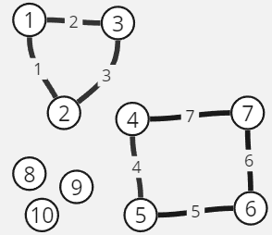 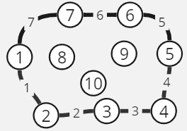

Both of these cases contain a cycle with odd number of vertices, and we know, that a cycle graph can be bipartite only if it contains an even number of vertices. That’s not the case, so our graph is **not** **bipartite**.

As there are 7 edges and every vertex, aside from isolated ones, has degree 2, each vertex can cover only two edges at a time. Hence, it’s impossible to cover all edges with only 3 vertices in vertex cover, as there will always be one edge left uncovered.

We can conclude that **optimal cover has to contain 4 vertices**. Examples of optimal cover for both cases are illustrated below.

